EA Refugia Salvage Event May 2025
In May 2025, Central Texas experienced above average temperatures, with highs exceeding 100°F for several consecutive days. These high temperatures and lack of significant rainfall further exacerbated prolonged drought conditions on the Edwards Aquifer spring systems, particularly the Comal springs system. On May 21, the Edwards Aquifer Habitat Conservation Plan (EAHCP) real-time water quality stations located in spring run 3 and spring run 7 of the Comal springs reported measurements that were abnormal. EAA staff went out to visually inspect the stations and found flow in both locations was insufficient for the equipment to record data (Figure 1). This occurred when total system discharge in the Comal system was approximately 50 cfs and the head at J17 and LCRA well were approximately 623 and 620.25, respectively (Figure 2).
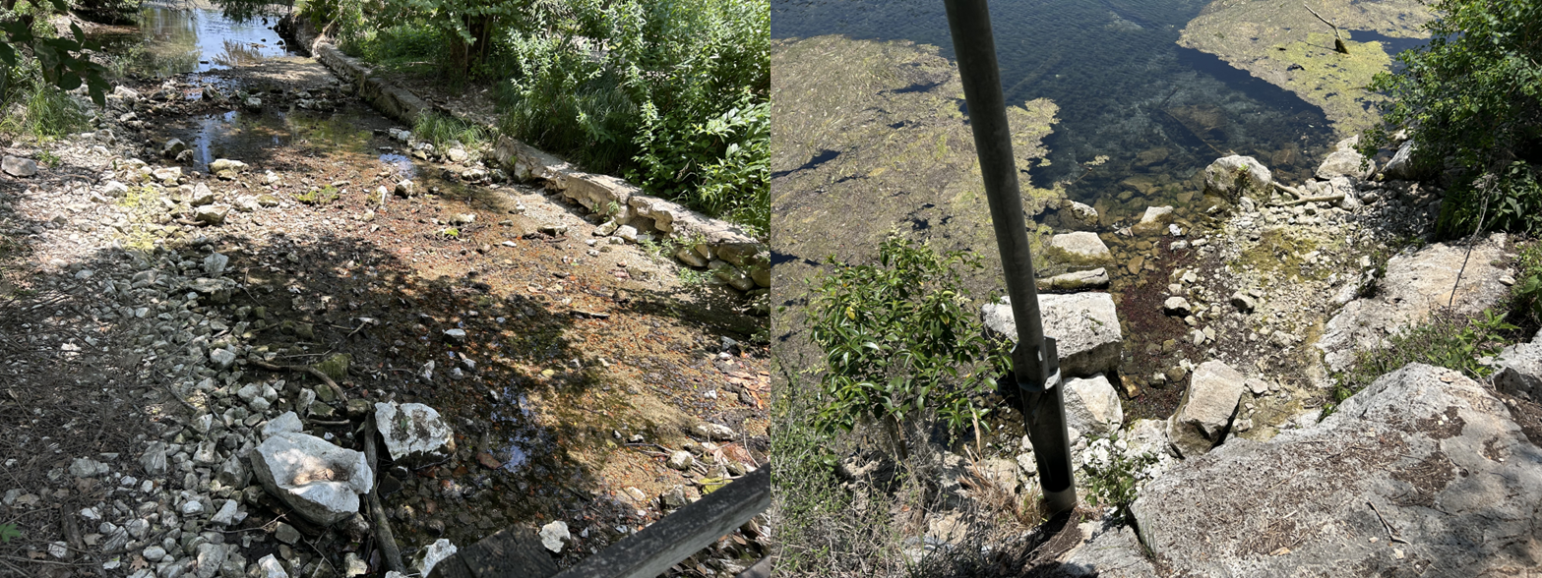
Figure 1. Conditions in Spring run 3 (left) and Spring run 7 (right) on May 21, 2025 that resulted in the inability to collect water quality measurements (pictures taken by EAA staff).

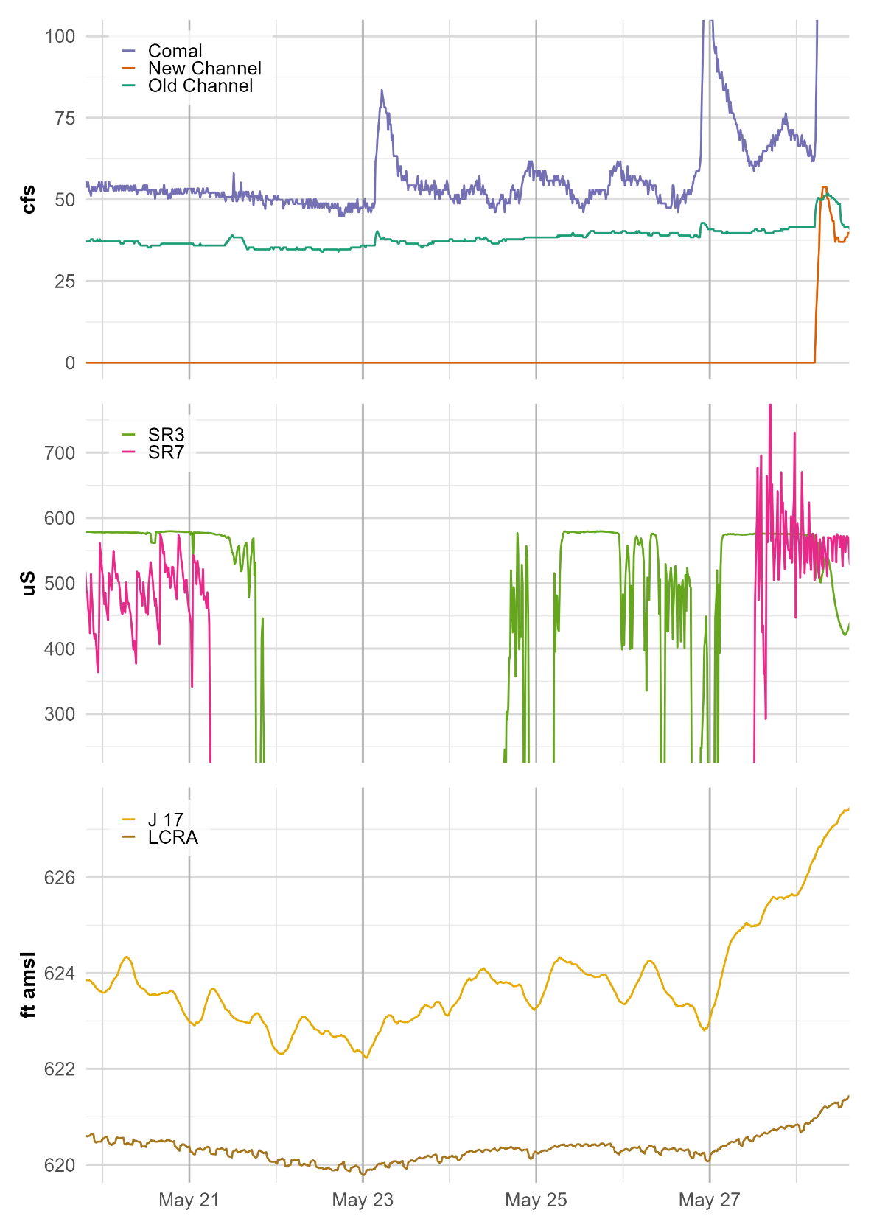
Figure 2. Time series of USGS surface water flow stations on Comal River (top panel): Comal River at New Braunfels (08169000), Comal River (new channel) nr Landa Lk (08168932), and Comal River (old channel) near Landa Lake (08168913). EAA surface water provisional data measurements of conductivity (middle panel) at Spring Run 3 and Spring Run 7. EAA well head provisional data (bottom panel) at J17 and LCRA wells. All measurements were taken at 15-minute intervals.
During the overnight hours from Wednesday May 21 to Thursday May 22, the lake dropped approximately 12 inches (reports were anywhere from 8-14 inches). By the evening of Thursday May 22, observations were reported that the Upper Spring Run had dissected from the remainder of the body of Landa Lake. The lowest values were reached in the overnight hours from May 22-23. The lows included: Comal (45 cfs), J17 well (622.23 ft), and LCRA well (619.78 ft). There were no disruptions in the Old Channel culvert/flow split. Figure 3 illustrates the drop in water levels and wetted area in the upper portions of Landa Lake near Spring Island at 70 cfs in March 2025 versus 50 cfs in May 2025.
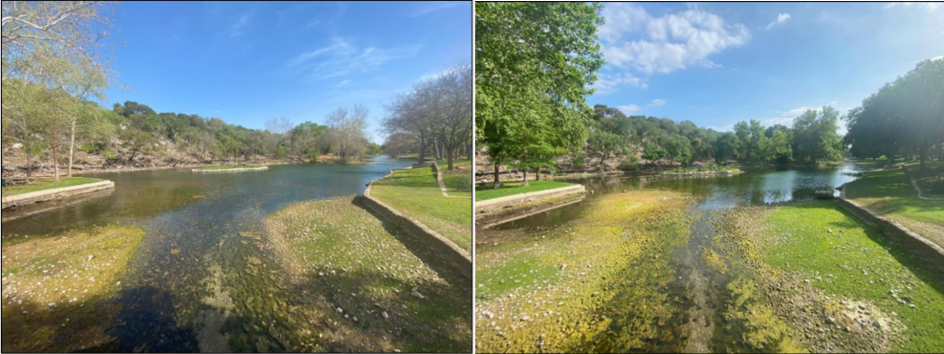
Figure 3. Wetted area near Spring Island in upper Landa Lake at 70 cfs in March 2025 (left) versus 50 cfs in May 2025 (right, pictures taken by Bio-West staff).
Given the large drop in water levels and reports of the upper portions of Landa Lake becoming separated from the main body of the lake, the decision to perform salvage of fountain darters in the upper portion of Landa Lake was made. The salvage event occurred before reaching designated EAHCP salvage triggers for the fountain darter (i.e.,<50% aquatic vegetation in Landa Lake and <20% fountain darter presence system wide ), but EAA and Refugia staff felt it necessary given the separation in habitats and the sudden drop in lake water levels. The median water temperatures in the upper portion of Landa Lake were also reaching 28°C, well above the EAHCP thresholds for fountain darters (Bio-West data).
On May 22-24, 2025, EA Refugia staff performed three salvage collection events for fountain darters in the upper portion of Landa Lake. A total of 2,295 darters were collected and transported to the EAHCP refugia facility at San Marcos Aquatic Resource Center (SMARC). Refugia staff reported darters in extremely dense clusters around remaining quality habitat.
Modest amounts of rainfall occurred on the 23rd and larger storms on May 26th and May 28th provided much needed recharge to the Edwars Aquifer. With the rains in late May, the aquifer levels rose and flows in the Comal system increased to near 90 cfs that reconnected the upper portions of Landa Lake to the main body and the spring runs began flowing again.
The salvaged fountain darters will remain in EA refugia facilities (i.e., SMARC and Uvalde) until at least the fall months when air temperatures decrease and the chance of rain increases. Spring flows will need to remain at current levels or increase before the fountain darters are returned to the lake. Per the EA Refugia contract, fountain darters can be housed for one year before needing to be released.

